Enter your email address and the password, elcpassword
Click Sign In button
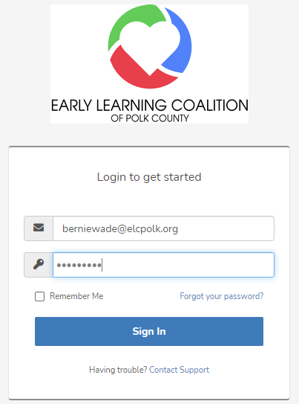

Agree to Term of Use Click on “I Agree” button
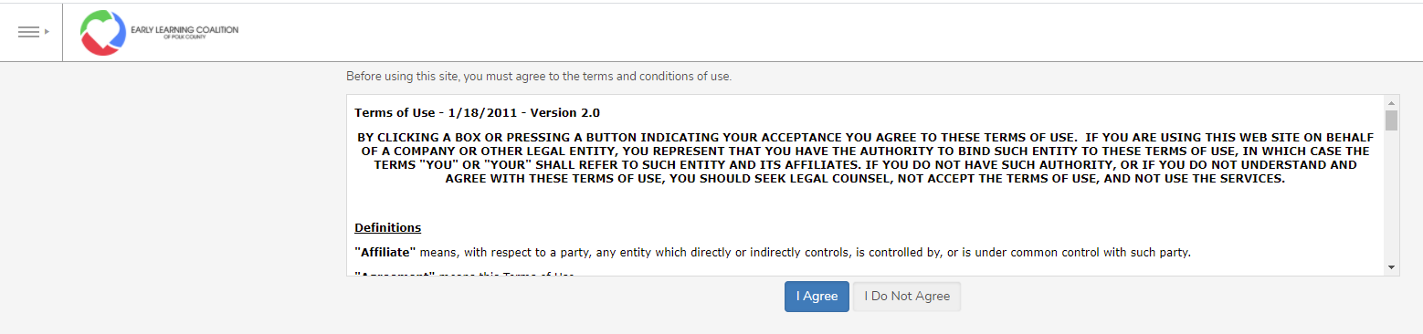

Enter New Password - Confirm Password – Click Change My Password button
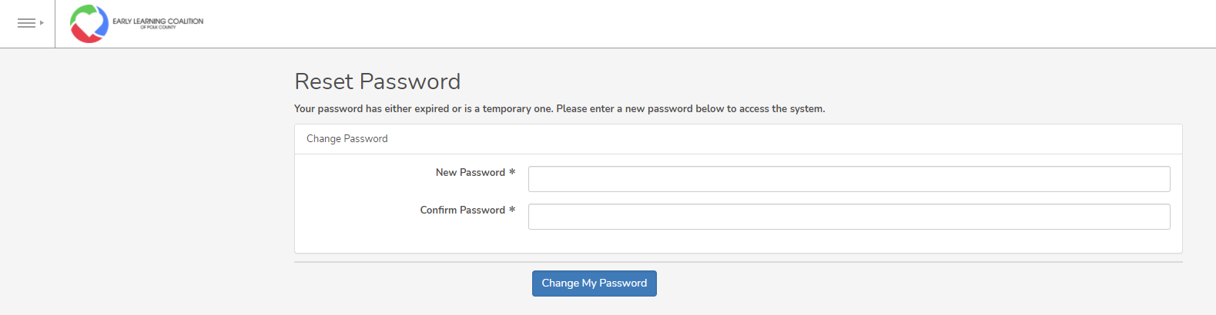

Complete Text Disclaimer
Enter your name
Personal Cell number
Select Child Care Facility from the dropdown list
Sign your name – Save
Enter Date you sign and click Submit button
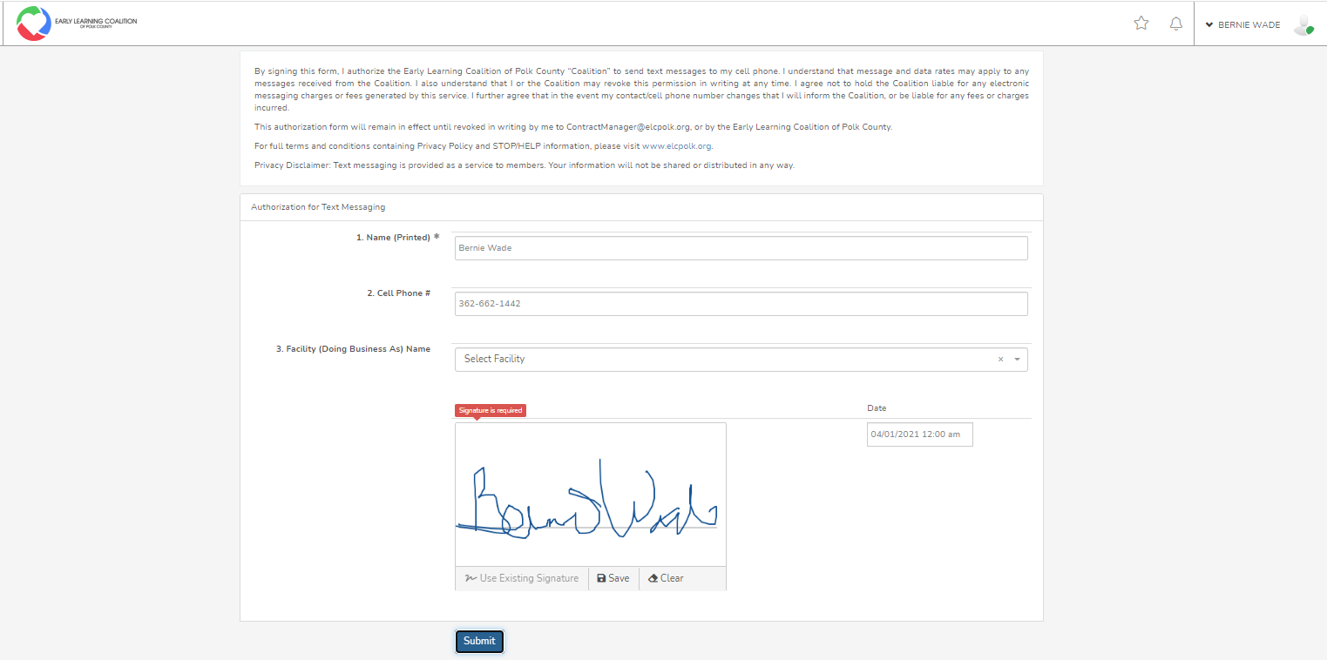

Click on the ELC logo

Click on the Training Classes menu

Click on the Click for more info or to register
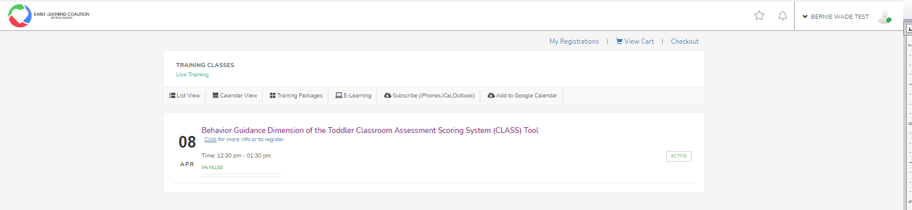

If you would like to register for the class Click on the Register button
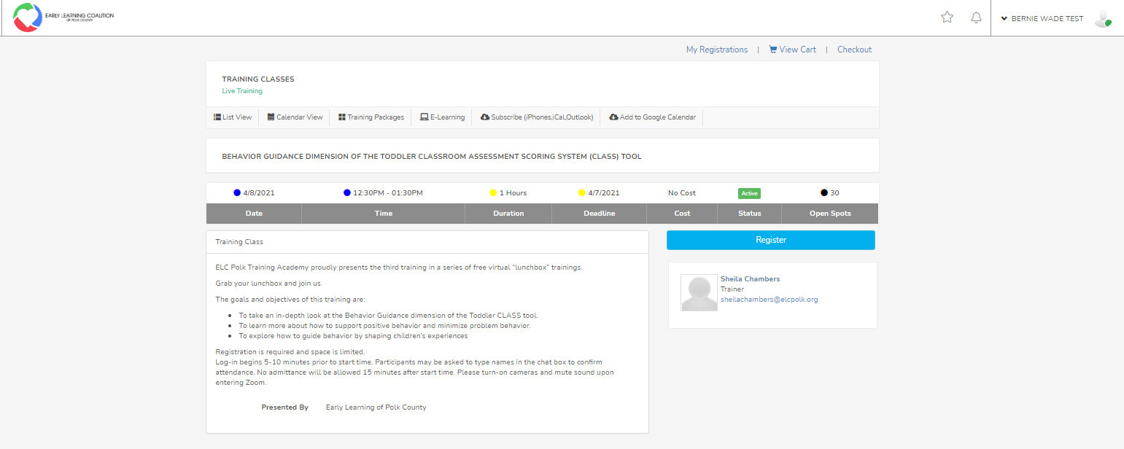
Click Checkout
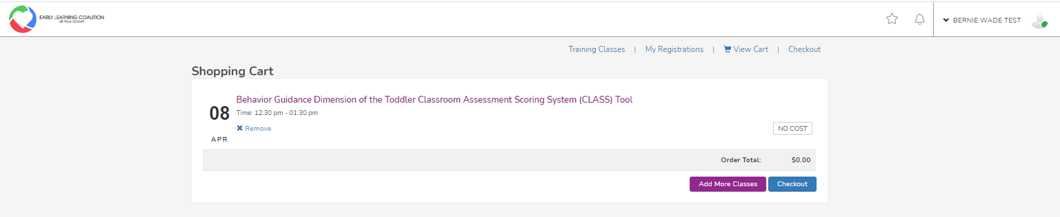
Fill out registration form
Select Childcare Provider name under Agency. If childcare Provider name is not listed enter Childcare Provider name in Agency Field. Click the Continue button
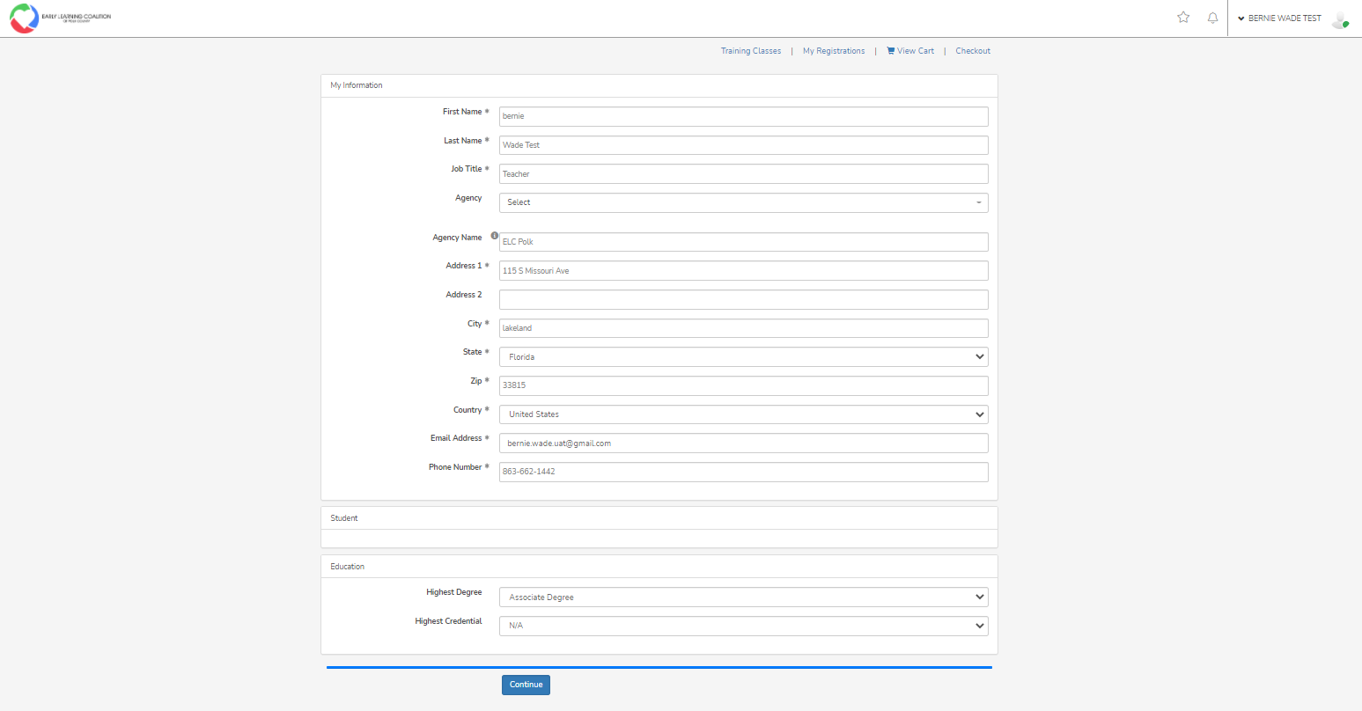

Click Complete Registration button
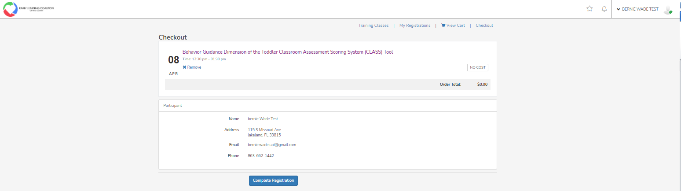
Training Receipt will display
