Emergency Recovery and Curriculum Provider Process

To access login page Click this link https://elcpolk.webauthor.com/go/rfp/
Click Apply
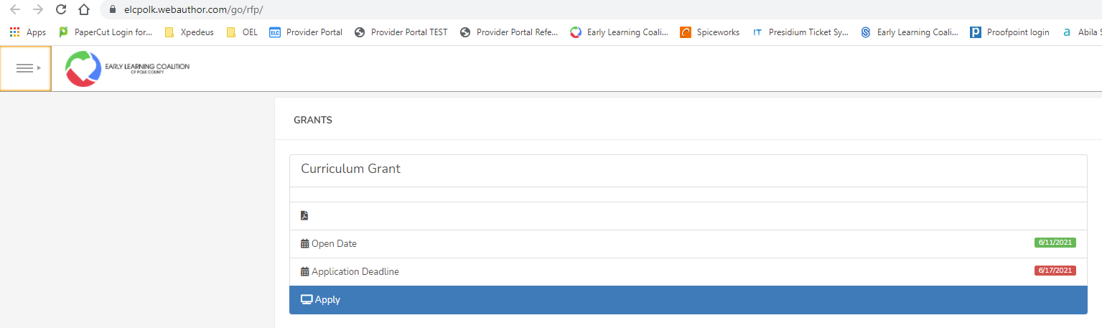

Enter User name and Password. Same user name and password used to complete Phase V Grant. Click Log In
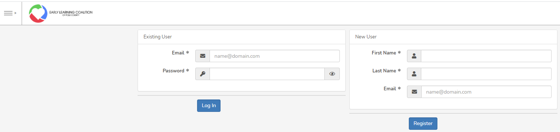

Click on the three horizontal lines located in the upper left hand corner. This will open the menu options. Select Applications
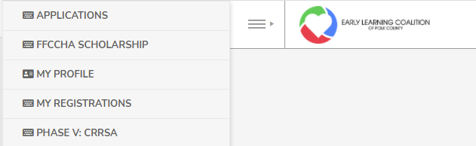

Click on New Record button
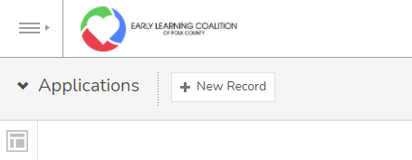
Complete form and Click Save. You application is compete and submitted
To Logout Click on your name located in the upper right hand corner. Click Logout

